Photo by: McKenna
I like your clover picture because the subject really stands out caused by the meshed objects in the background. The lighting and colors for the picture are perfect.

Photo by: Gracie
I really like your Parking Line image, because the image was taken at a great angle and position to really allow the texture to stand out. 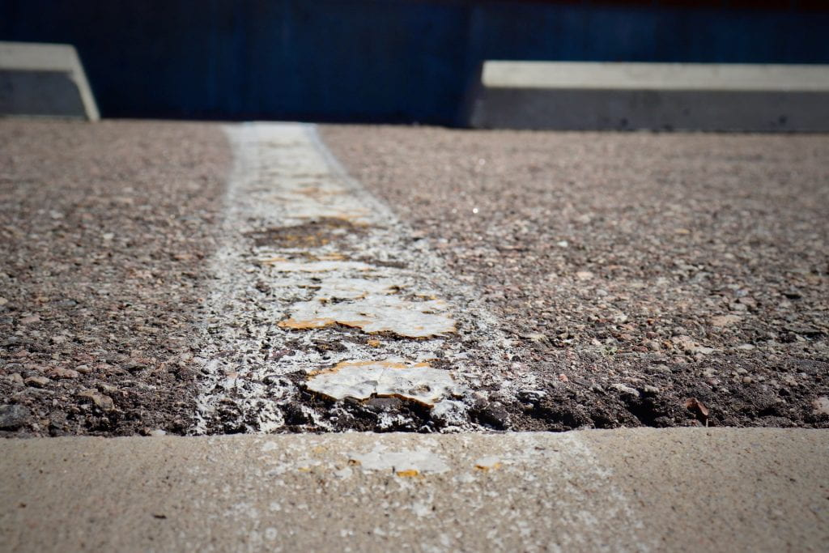

Photo by: Brock
Your Paved Road photo has a nice tone to it. The lighting and position of the photo makes the picture show how detailed the road is. 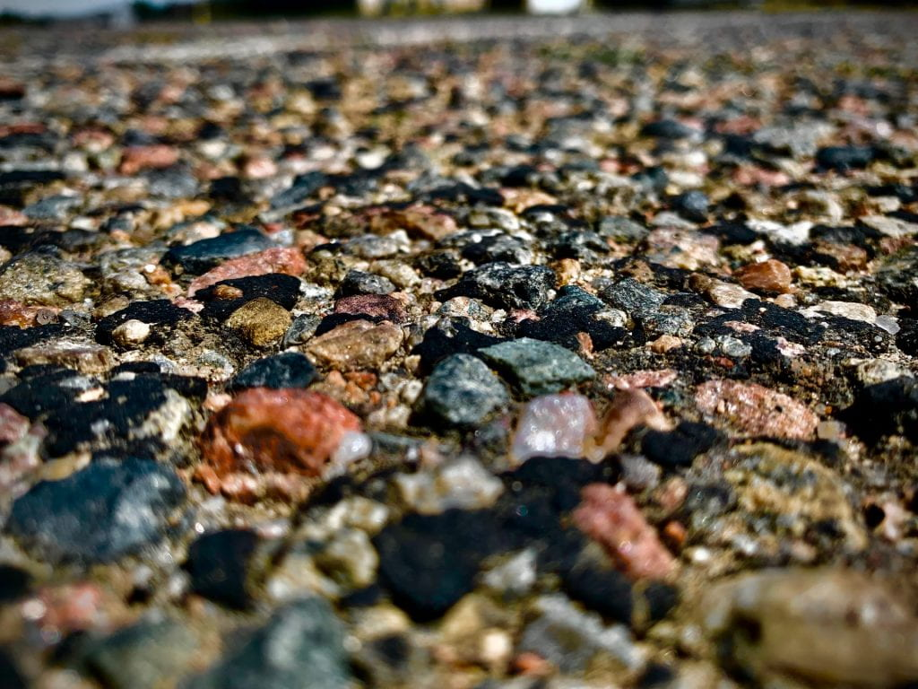

Photo by: Tegan
Your Brick Wall photo has a nice angle that allows the roughness of the brick to stand out. A suggestion I have is that I would change the lighting of the photo because the bricks don't hane any shadow on them to express the texture.
