Photo by: McKenna
I really like your picture with the fence in it because it shows depth. the fence stands out because of the blur of the background and the coloring of the fence.
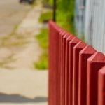

Photo by: Gunther
Your gift shop photo has a very nice angle that allows the words and sigh to stand out. The cut off of the words adds an additional touch to it allowing the space needed to really make the subject stand out.

Photo by: Camille
I like your Electricity Pole photo because the angle of where the photo was taken, makes you get the perspective and feeling that an ant would have looking at the same object.

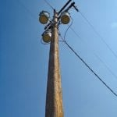

Photo by: Elana
I like this photo because the color of the grapes makes them stand out from the green leafy background. The lighting in this photo is also very good by the way the sun is shining on the grapes.
