Photo by: McKenna
I like your Leaf Me Alone photo because the shadow of the other leaves make the photo look like the sun is shining through the leaves in a shadowy form.

Photo by: Jackson
Your cage fence photo is very nice because the lighting on the fence adds depth and volume to the subject.

Photo by: Jackie
I like your Path of Light photo because the lighting has a way of making the picture look like a joyful place. The lighting in this photo plays a very big part and is really emphasized well.
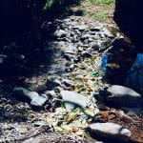

Photo by: Stephanie
I like your street food picture because the angle that it was taken at allows the shadow of the apple to give it some shape and depth.
