Many people might not consider photography as art. I personally am very confused about what people consider modern art. Art is a way to express your feelings. There are many ways that you can show art, and photography is one of those ways. Photography is a very modern style of art. There are many things a photo can describe. One problem with photography is that everything has to be perfect or else it won’t turn out well. A good photo has a main subject, a semi-empty background, and the correct light can help. If a photo has a lot of stuff in the foreground, that can lead the viewers away from the subject. Another flaw is if the lighting is off. The lighting in phot has to be exact. If there is to much light, the photo and its subjects will look white, and the forms will look messy. Just like if you have to much light, you can also have not enough light. If you take a picture with not enough light, your subjects won’t be seen because your picture will be black. These are the two main factors that will determine if a photo is good or not.
There are two different styles of photography: snapshot and fine art. A snapshot is when someone takes a picture without any planning on the position of the camera, the lighting, or the background. These are the kind of pictures an average person would take using their phone. A fine arts photo is where everything is planned and set to perfection. These photos can be created in a studio, or they can be edited to the photographer’s preference. Most professional photographers take these kinds of photos.
This phot is an example of a snapshot. There is a lot of random stuff in the background as well as in the bottom of the picture. The lighting is also off. There is too much light it takes away the natural color of the subject.
Here is another example of a snapshot. Just like the previous photo, there is a lot of clutter of unnecessary items. Although the previous pictures lighting is bad, the lighting in this picture allow the colors to stand out naturally.
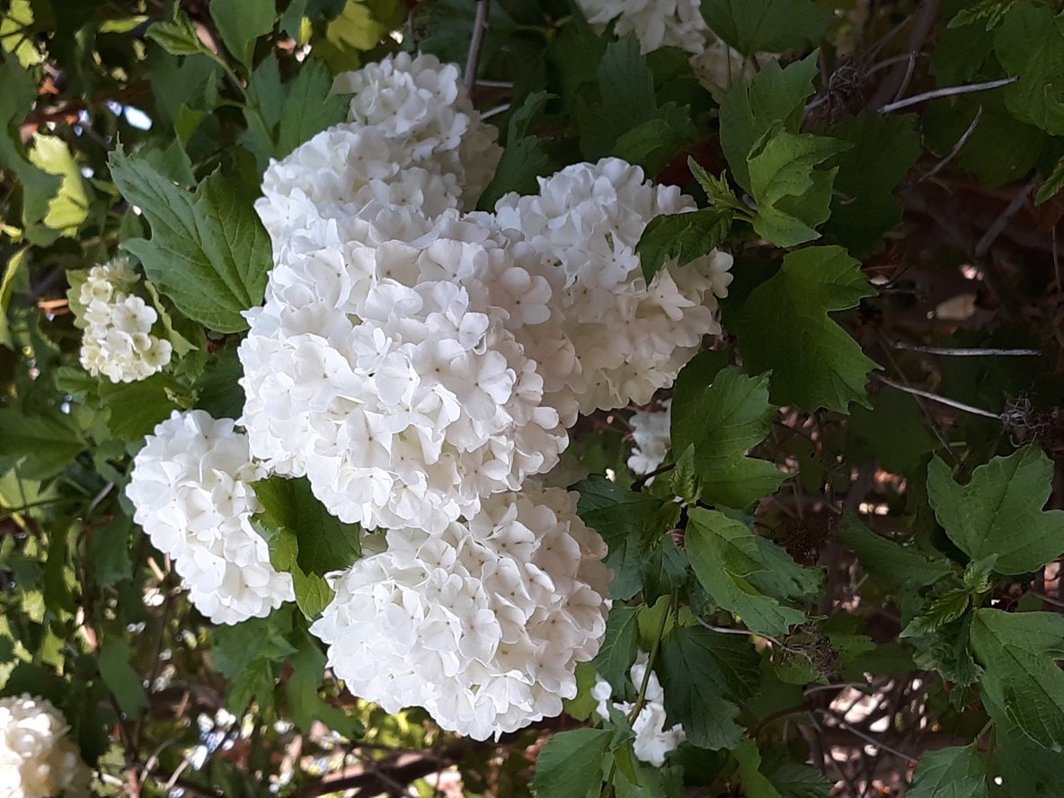
This photo is a very fine picture. It has the subject alone with a natural background of leaves and branches. The lighting is also good. The flowers have a little bit of shadow which allows the photo to have a 3D look.
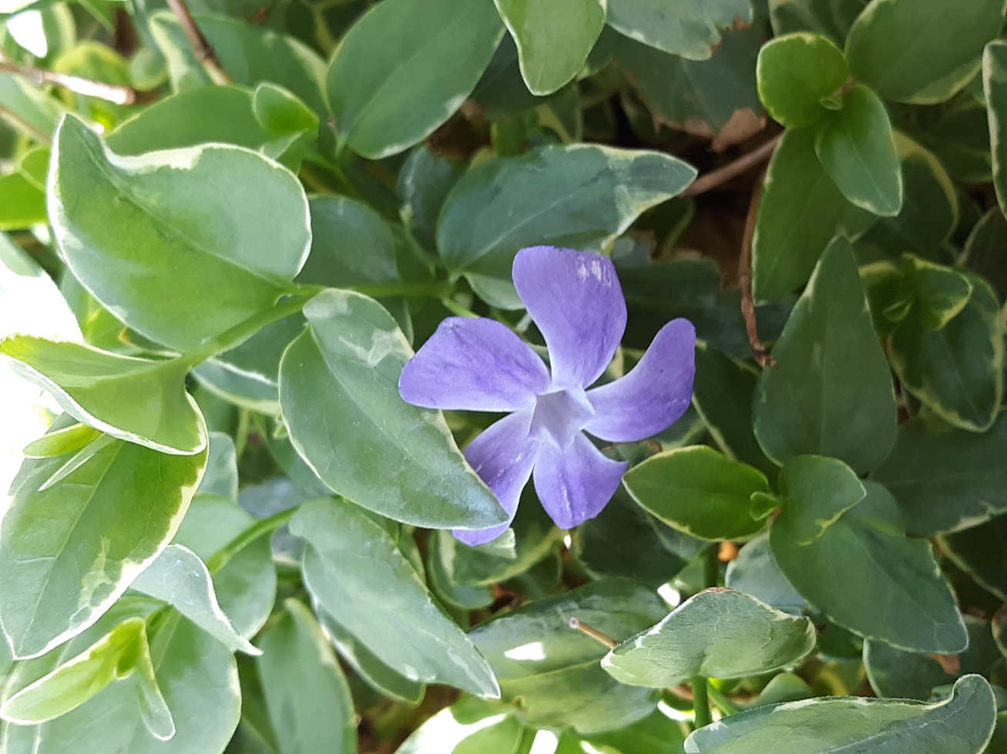
This photo would be an above average photo when it comes to a phone. The lighting is great. You can identify where the sun might have been by the way the photo gradually gets lighter as you look left. The photo is not blurry, and the subject stands out from the background. The background in this picture does not take away the pizazz of the subject.

