Photo by: McKenna
I like your Hills picture because it is in focus and the detail stands out. Turing the photo to black and white allows the texture to stand out and gives the photo a realistic 3D look.
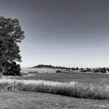

Photo by: Sady
I love your Sunset with Mountains photo because the coloring and lighting of the sunset allows the mountains shape to stand out. It shows the volume and intensity of the earth.
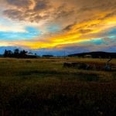

Photo by: Jackie
I like your Noir photo because the black and white filter allows the texture of the tree and size of the mountain to really show, and the power is not being taken away by the color.
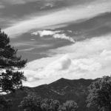

Photo by: Morgan
I love your Purple Snow photo because the snow, the coloring of the outside is able to be seen more clearly. This is a really great photo.
