Photo by: Ady
I like your Waterfall photo because the black and white filter that you put on it really allows the texture and shape, the water makes, stand out.
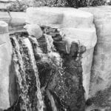

Photo by: Amelia
I like your Squeeze Chute photo because the lighting of it makes it look like a vintage photo ad it has a very nice color to the triangle.

Photo by: Jackson
I like your Wall of Splinters Because the texture of the wall stands out because of the effect the lighting has on the photo.
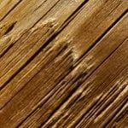

Photo by: Stephanie
I like your Green Leaves photo because the lighting of the photos makes it look like it is shining from the underside of the leaves.

