Photo by: McKenna
I like your Wee Woo Wee Woo picture because the angle of the photo really shows the texture of the front of the jeep.

Photo by: Jackie
I like your Comfy photo because of the way the lighting is, it makes the water bottle stand out and gives the photo a 3d look.
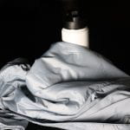

Photo by: Jackson M.
I Like Your Star Photo Because The Black And White Filter Makes The Star Look Very Realistic And Makes Me Feel Like I Am Really There.

Photo by: Stephanie
I like your Don't Be Sour photo by the way you used the lemon to fill the frame.
