Photo by: Jackie
I like your picture of the camera because of the angle and viewpoint the photo was taken at.
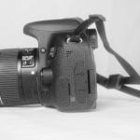

Photo by: Kim
I like your Mood Board photo because the set up and angle go together as well as the lighting and background. This is a good photo.

Photo by: Gracie
I like your basketball photo because of the placement of the ball. It gives the picture some depth.

Photo by: Amelia
I like your athletic tape picture because of the coloring of the tapes and the blurred tapes in the background give the picture some depth.
